HRA study guide:
Congratulations, you’ve made it to the end of the course! Now it’s time to prep for the final. The final is a 60 question m/c exam covering all the material you’ve been learning about. This study guide will break it down again so you can assess what areas you may need to focus on. Please be aware that this study guide is only an overview of the course, and may not contain ALL the information in detail regarding each of the topics. It is meant to test your knowledge, not serve as a replacement for class or self-study.
Contents
Types of Data 3
Fill in the Blank 3
Multiple Choice: 3
Making a null and alternate hypothesis 4
Fill In The Blank 4
Multiple Choice: 5
Type I and Type II errors 6
Fill In The Blank 6
Multiple Choice: 6
Sampling, Reliability and Validity 7
Fill in the Blanks 7
Multiple Choice 8
Confidence Intervals 9
Fill in the Blank: 9
Multiple Choice: 10
Graphs 11
Fill in the Blanks: 11
Match: 11
Multiple Choice: 11
HALF-WAY POINT: THEORY EXAM M/C 12
Chi-Squared Analysis 13
Fill in the Blanks 13
Multiple Choice 13
Output Images 14
Correlation 18
Fill in The Blank: 18
Multiple Choice: 18
Output images and questions: 19
T-Test 22
Fill in the Blank 22
Multiple Choice 22
Output 25
ANOVA 28
Fill in the Blank 28
Multiple choice 28
Output 30
Walk through 33

HRA study guide:
Congratulations, you’ve made it to the end of the course! Now it’s time to prep for the final. The final is a 60 question m/c exam covering all the material you’ve been learning about. This study guide will break it down again so you can assess what areas you may need to focus on. Please be aware that this study guide is only an overview of the course, and may not contain ALL the information in detail regarding each of the topics. It is meant to test your knowledge, not serve as a replacement for class or self-study.

Types of Data
What do you need to know:
    - The 4 different types of variables: Nominal, Ordinal, Interval, Ratio
    - The terms categorical data and continuous data

Fill in the Blank
- The data type used to categorize things like gender, nationality, or types of cuisine is __________. (nominal)
- Temperature measured in Celsius or Fahrenheit is an example of a(n) __________ scale because it has equal intervals but no true zero. (interval)
- An example of __________ data is ranking students as first, second, or third based on their performance in an exam. (ordinal)
- Data like weight or height, which allows for the calculation of meaningful ratios, is measured on a __________ scale. (ratio)
- IQ is ranked on a scale of 70-140. This is an example of _____________ data. (interval)
- Rank is the army would be considered ______________ data. (ordinal)
- A researcher collects information about subjects favourite fruit. This is ________data. (nominal)
- I record how long people sleep on average per week. My data type is ___________.(ratio)
- __________ and___________ are considered categorical data. (nominal/ordinal)
- __________ and ______________ are considered continuous data. (ratio/ interval)

Multiple Choice:
What is variable type has an absolute 0 point?
- nominal
- ordinal
- interval
- ratio

Which of the following is an example of ordinal data?
- Height in meters
- Level of schooling completed
- Gender (Male, Female, Other)
- Age in years

In a survey, respondents are asked to pick their favourite type of cuisine (e.g., Italian, Mexican, Chinese). What is the data type?
- Ordinal
- Interval
- Nominal
- Ratio

Which of the following variables is most likely measured on an interval scale?
  - Distance travelled in kilometres
  - Temperature in Fahrenheit
  - Number of students in a class
  - Ranking of employees based on performance

Making a null and alternate hypothesis
What do you need to know:
- To formulate good null- and alternative hypotheses (H0 and Ha/H1).
- When to use µ versus π (hint: look at the type of variable you are measuring)

Fill In The Blank
- The __________ hypothesis states that there is no effect or no difference between groups or variables. (null)
- The __________ hypothesis proposes a specific effect or relationship that the researcher aims to test. (alternate)
- In hypothesis testing, the null hypothesis is often denoted as __________. (H0)
- The alternative hypothesis is symbolized as __________ and suggests that there is a significant effect or difference. (H1/Ha)
- When a researcher claims that a new treatment works better than the standard treatment, this is an example of the __________ hypothesis. (alternate)
- In hypothesis testing, μ represents the __________ in a population (average)
- The null hypothesis for testing if the average height of adults is 170 cm would be written as __________ . (µ=170)

- If a researcher believes the average weight of a population is greater than 70 kg, the alternative hypothesis would be written as __________ . (µ>70)

- The symbol π is used to represent the __________ of a population. (percentage/proportion)

- In a study comparing the proportion of males and females who drive, the null hypothesis would be 𝐻0 : 𝜋 males = 𝜋 females, while the alternative hypothesis could be______________ . (𝜋 males ≠ 𝜋 females)

Multiple Choice:

- A hotel chain wants to find out how their guests heard of their hotel. They are especially interested in whether more guests heard about their hotel through TRIVAGO than through Google. So guests were asked the question: “How did you find us?” 35% of 200 respondents mentioned Google and 40% TRIVAGO. Which hypothesis fits the question of the hotel chain?
  - H0: πGoogle = πTRIVAGO H1: πGoogle ≠ πTRIVAGO
  - H0: πGoogle < πTRIVAGO H1: πGoogle ≥ πTRIVAGO
  - H0: πGoogle ≥ πTRIVAGO H1: πGoogle < πTRIVAGO
  - H0: πGoogle > πTRIVAGO H1: πGoogle ≠ πTRIVAGO

- After a large scale anti-smoking campaign in 2019, the Trimbos institute wants to test whether the percentage of smokers in the Dutch population has decreased. The last big survey from 2009 showed that at that time 35% of the population smoked. Which hypothesis fits the question from the Trimbos institute?

  - H0: π = 0.35 H1: π ≠ 0.35
  - H0: π ≤ 0.35 H1: π > 0.35
  - H0: π ≥ 0.35 H1: π < 0.35
  - H0: μ ≥ 0.35 H1: μ < 0.35

- A researcher wants to find out if there is a difference in voting amount due to gender. They record how many of each come to the voting booths. Which hypotheses fit what they are doing?

  - H0: π men = π women H1: π men ≠ π women
  - H0: π men < π women H1: π men ≥ π women
  - H0: μ men ≥ μ women H1: μ men < μ women
  - H0: μ men ≠ μ women H1: μ men = μ women

- It is believed that 70% of the hotel guests use the free Wi-Fi service. A researcher is investigating whether the proportion of guests using Wi-Fi is less than 70%. What are the null and alternative hypotheses?
- H0: π=0.7 HA: π≠0.7
- H0: π≥0.7 HA: π<0.7
- H0: μ=0.7 HA: μ<0.7
- H0: μ≤0.7 HA: μ>0.7

- The average room service delivery time at a hotel is claimed to be 30 minutes. The hotel is testing whether the actual average delivery time has decreased after new policies were implemented.

  - H0​: π =30 HA: π ≠ 30
  - H0​:μ ≥ 30 HA:μ < 30
  - H0​: π ≥ 30 HA: π < 30
  - H0​:μ ≤ 30 HA:μ > 30

Type I and Type II errors
What do you need to know:
    - What is a Type I error and the symbol associated with it
    - What is a Type II error and the symbol associated with it
  - Tips on how to answer these question:
    - Figure out your null and alternate hypothesis
    - Figure out which hypothesis you are choosing, and which one you should have chosen.

Fill In The Blank
- When a true null hypothesis is rejected, a ______________ error has occurred. (Type 1)
- The probability of making a Type I error is denoted by the Greek letter _______. (α alpha)
- The probability of making a Type II error is represented by the Greek letter ______. ($β$ beta)
- A Type II error is also known as a ________________ (false negative)
- When a true alternate hypothesis is rejected, this is a _________error. (Type 2)
- Failing to reject a false alternate hypothesis is a _____________error. (Type 1)
- In a criminal trial, a Type I error would mean convicting an ______________ person. (innocent)
- In an environmental study testing for water pollution, a Type II error would mean concluding that the water is ____________ when it is actually polluted. (clean/safe)
- In a medical test for a rare disease, a Type I error would mean that a ________person is diagnosed incorrectly. (healthy)
- Failing to reject a false null hypothesis would be a _________error. (Type 2)

Multiple Choice:

    - A hotel claims its room service delivery time is 30 minutes on average. A manager tests whether the delivery time is different from 30 minutes. A Type I error in this scenario would mean:
- Concluding the delivery time is different from 30 minutes when it is actually 30 minutes.
- Failing to detect that the delivery time is different from 30 minutes when it is not.
- Concluding the delivery time is longer than 30 minutes.
- Failing to conclude that the delivery time is 30 minutes.

    - The hotel management believes that the average guest satisfaction rating is 8 out of 10. They want to test if it has decreased. A Type II error would mean:

- Concluding that the satisfaction rating is 8 when it has actually decreased.
- Concluding that the satisfaction rating has decreased when it has not.
- Failing to detect an increase in the satisfaction rating.
- Failing to detect that the rating has decreased when it actually has.

    - The hotel claims that 90% of guests are satisfied with the complimentary breakfast. A manager wants to test whether this proportion has changed. A Type II error would mean:

- Concluding the satisfaction rate is different from 90% when it is still 90%.
- Failing to detect that the satisfaction rate has changed when it actually has.
- Concluding that the satisfaction rate is less than 90%.
- Concluding that the satisfaction rate is higher than 90%.

    - The hotel manager is told that the proportion of cancelled bookings is 5%. A researcher tests whether the cancellation rate is higher than 5%. A Type I error occurs if:

- Concluding that the cancellation rate is higher than 5% when it is actually 5% or less.
- Failing to detect that the cancellation rate is higher than 5% when it is.
- Concluding that the cancellation rate is lower than 5%.
- Failing to reject that the cancellation rate is 5% or less when it is higher.

    - The hotel management has recorded that less than 5% of guests complain about noise levels. They test to see if the complaint rate is actually higher than 5%. A Type II error would occur if:

- Failing to detect that the complaint rate is higher than 5% when it actually is.
- Concluding that the complaint rate is higher than 5% when it is actually lower.
- Concluding that the complaint rate is exactly 5%.
- Concluding that the complaint rate is less than 5%.

Sampling, Reliability and Validity
What do you need to know:
    - The difference between probability and non-probability sampling
    - The 8 different types of sampling
    - The 6 different types of validity
    - How reliability and validity interact

Fill in the Blanks

- In _______________ sampling, each individual in the population has an equal chance of being selected, and selection is typically done using random numbers or lottery methods. (simple random)
- _______________ sampling divides the population into different subgroups based on shared characteristics, then randomly selects samples from each subgroup to ensure representation. (stratified)
- In _______________ sampling, every nth member of the population is selected after randomly choosing a starting point, ensuring a consistent selection process across the population. (systemic)
- _______________ sampling involves dividing the population into naturally occurring groups and then randomly selecting entire groups to be studied, rather than individuals. (cluster)
- _______________ sampling selects individuals who are easiest to reach or readily available, often used when time or resources are limited. (convenience)
- ______________ sampling involves selecting participants to fill specific requirements (e.g., gender or age categories) to ensure that certain subgroups are adequately represented in the sample. (quota)
- In _______________ sampling, participants decide whether or not they want to be part of the sample, often in response to an open call for volunteers. (self-selection)
- In ______________ sampling, participants are recommended by others who have completed the research. (snowball)
- _______________ validity refers to how well a test or measure appears to measure what it is supposed to measure. It can also involve a second opinion, or approval by an expert. (Face)
- _______________ validity assesses whether a test measures the theoretical concept or construct that it is intended to measure. (Construct)
- _______________ validity is demonstrated when a new test correlates well with a well-established, existing test that measures the same construct. (Criterion)
- ______________ validity examines whether the test covers all relevant content areas of the construct it aims to measure (Content)
- Good research should be both __________ and __________ (reliable/valid)
- ______________ validity refers to how well the findings of your research can be applied to others.
- A lack of control over extraneous variables, such as differences in testing environments, can lower a study's _______________ validity. (internal)

Multiple Choice

1. A hotel management team wants to ensure that a guest satisfaction survey accurately measures overall satisfaction, not just specific aspects like service or cleanliness. This is a concern for:
- Construct validity
- Face validity
- Criterion validity
- Internal validity
2. A hotel’s customer satisfaction survey looks professional and relevant to the topic of guest satisfaction. Based on this, a researcher claims that it measures satisfaction well. This is an example of:
- Content validity
- Face validity
- Criterion validity
- Construct validity

3. A new satisfaction survey is created for hotel guests. To test its _______________ validity, researchers will compare the survey’s results to actual booking data and repeat visits from guests.
- Construct
- Criterion
- Internal
- Content
4. A hotel manager decides to conduct interviews with the first 20 guests who arrive at the front desk to check in. This is an example of:
- Convenience sampling
- Systematic sampling
- Snowball sampling
- Stratified sampling
5. A hotel manager wants to survey 100 guests randomly from a guest list to assess overall satisfaction. Every guest has an equal chance of being selected. What type of sampling is being used?
- Stratified
- Convenience
- Simple random
- Cluster

Confidence Intervals
What do you need to know:
    - What a confidence interval is
    - How sample size affects a confidence interval
    - Why confidence intervals are used
    - What is one-tailed vs two-tailed testing

Fill in the Blank:

- As the sample size increases, the confidence interval becomes _______________ because there is more information to estimate the population parameter. (narrower/ more precise)
- For a fixed sample size, increasing the confidence level from 90% to 99% will make the confidence interval _______________. (wider)
- The upper/lower value of a confidence interval is also called a _________ value (critical). This is the threshold for significance.
- For something to be significant, p must be lower than _________ (0.05), if the confidence interval is set at 95%
- A _______________-tailed test is used when the research hypothesis specifies a direction of the effect (e.g., higher or lower than a certain value). (one)
- A _________ is the population parameter you collect from your sample (point estimate)
- If the alternative hypothesis suggests that hotel occupancy rates are greater than 80%, then the appropriate test is a _______________ test. (one-tailed)
- If we wanted to make our confidence interval as precise as possible, we would need to increase the ________ (sample size).
- In a confidence interval written as 200±5 could also be written as ______________(195-205)
- The width of a confidence interval depends on the sample size and the _______________ of the data (variability/standard deviation)

Multiple Choice:

1. A 95% confidence interval for the average nightly rate at a hotel is $120 to $150. What does this mean?
- The true average rate is exactly $135.
- There is a 95% risk that the true average rate is not between $120 and $150.
- We are 95% confident that the true average rate is between $120 and $150.
- 95% of the rates are between $120 and $150.
2. Which of the following is not a factor that affects the width of a confidence interval?
- Sample size
- Confidence level
- Variability of the data
- Sample mean
3. If the confidence interval for the mean price of a hotel room is $90 to $110, what is the sample mean price?
- $90
- $100
- $110
- $95
4. What effect does increasing the sample size have on a confidence interval, assuming everything else remains constant?
- It makes the confidence interval wider.
- It has no effect on the confidence interval.
- It makes the confidence interval narrower.
- It decreases the confidence level.
5. What are the critical values of the following confidence interval: 100±10
- 100 and 10
- 0.05
- 90 and 110
- 110 and 120

Graphs
What do you need to know:
    - When to use which graph
    - What graph is associated with each variable type

Fill in the Blanks:
When you need to represent an ordinal variable such as satisfaction levels (Poor, Fair, Good, Excellent), a __________ chart is appropriate. (barchart/pie char)
When showing the range and spread of data like test scores, including the median and quartiles, a __________ is the best graph. (box plot)
When plotting two continuous variables to show their relationship, like height and weight, a __________ plot is commonly used. (scatterplot)
A __________ graph is best for displaying the distribution of a continuous variable such as temperature. (histogram).
Visualizing data about peoples nationality versus their average distance travelled to work should be visualized as a ___________________(bar chart/ box chart/ error bar plot)

Match:
2 categorical variables | Histogram
1 categorical variable | Pie chart
1 continuous variable | Scatterplot
2 continuous variable | Clustered barchat
1 continuous and 1 categorical | Box plot

Multiple Choice:

Which type of graph is best suited for displaying the distribution of a single continuous variable?
A) Bar chart
B) Line graph
C) Histogram
D) Scatterplot

A hotel manager wants to show the relationship between the number of years of staff experience and customer satisfaction scores. Which graph should they use?
A. Scatter plot
B. Bar chart
C. Pie chart
D. Box plot

A restaurant owner wants to compare the average monthly revenue across four different branches. What is the best type of graph for this comparison?
A. Pie chart
B. Bar chart
C. Scatter plot
D. Histogram

When creating a bar chart, what variable is typically used for the x-axis (horizontal axis)?
A) The dependent variable
B) A categorical variable (ordinal/nominal)
C) The measured variable
D) A continuous variable (scale)

HALF-WAY POINT: THEORY EXAM M/C

Chi-Squared Analysis
What do you need to know:
    - When do you use a Chi square
    - What are the data prerequisites
    - How do you calculate expected count
    - How do you read an output window of a Chi square analysis

Fill in the Blanks
- The Chi-squared test is used to determine if there is a significant association between two __________ variables. (categorical)
- The formula for expected counts is_________________([row total x column total]/ grand total)
- The Chi-squared test can only be used if the expected count in each category is greater than __________.
- A Chi squared test compares expected values to __________ values. (observed)
- The relationship of the variables is quantified using ___________.(Cramers V)
- The null hypothesis in a Chi-squared test states that the two variables are __________. (not related)
- A Cramér’s V value close to 0 indicates a __________ relationship between the variables. (weak).

Multiple Choice

1. What type of variables are required for a Chi2 test?
- Categorical variables
- Continuous variables
- Quantitative variables
- Parametric variables
2. What is the main purpose of a Chi2 test?
- To test hypotheses about means
- To calculate effect size
- To determine population parameters
- To assess relationships between categorical variables

3. In a chi squared test, what do the expected values represent?
- Expected values represent what would be seen if the null hypothesis was true.
- Expected values represent values obtained from previous studies
- Expected values represent values that are always higher than observed values
- Expected values represent values predicted by the researcher

4. What values do we compare in a chi squared test?
- Recorded values and null hypothesis values
- Expected values and predicted values
- Actual values and statistical values
- Observed values and expected values

4. What is the data prerequisite for the Chi² test?
- Expected counts cannot be more than 5
- Expected counts cannot be less than 5
- Data must always be visualized first
- Observed values counts must be calculated

Output Images
1.
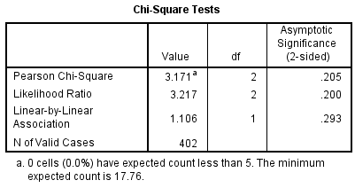
What is the p-value:___________(0.205)
Is this relationship significant? _____________(no)

2.
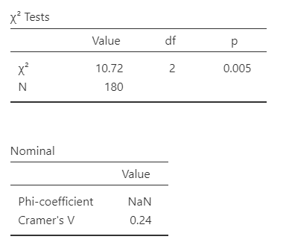
What is the p-value?_______(0.005)
Is this relationship significant? __________(yes)
Is the relationship strong? Why or why not?_________________________ (no, weak Cramer’s V)

3.
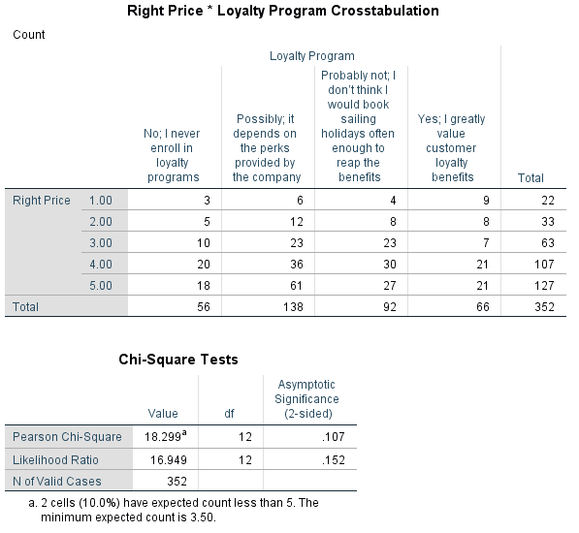
Is this result valid? Why or why not? _____________________(no, expected counts less than 5)
What is the p-value:_____________ (0.107)
Is there a significant relationship?__________(no)

4.
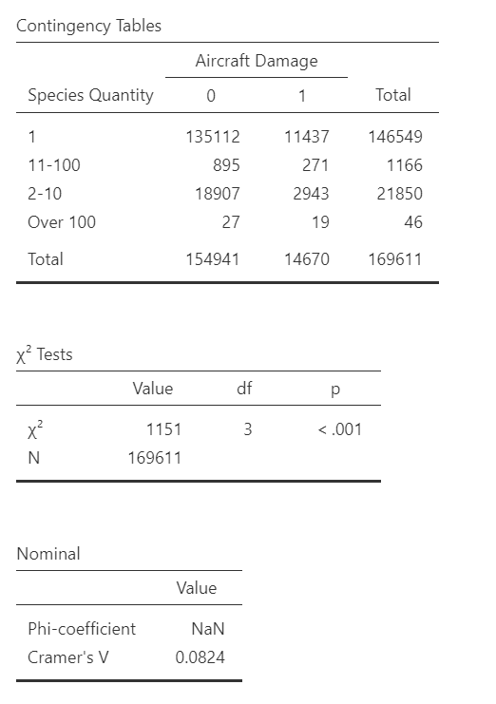
What is the expected cell count for aircraft damage 1 vs over 100 Species? ________________(46*14670/169611= 3.98)
What is the appropriate conclusion to the above image?____________________________________(this test is not valid as there is an expected count of less than 5)

Correlation
What do you need to know:
    - When do you use a correlation
    - What are the data prerequisites
    - How do you read an output window of a Correlation (Pearson’s R vs p-value)

Fill in The Blank:

- The Pearson correlation coefficient is represented by the letter __________.(r)
- The Pearson correlation coefficient ranges from __________ to 1. (-1)
- A Pearson correlation coefficient of 1 or -1 indicates a __________ relationship between the variables. (perfect/strong)
- In order to run a Pearson’s correlation, our data must be __________ when visualized. (linear)

- A positive Pearson correlation indicates that as one variable increases, the other variable __________. (also increases)
- A negative Pearsons correlation indicates that as one variable increases the other variable ___________. (decreases)
- Pearson’s correlation is only appropriate for __________ variables that have a linear relationship. (continuous)

Multiple Choice:

- What does Pearson’s correlation measure?
a) The presence of other variables outside the two being explored
b) The linear relationship between two variables
c) The cause and effect between two variables
d) The accuracy of describing curvilinear relationships

- How is correlation measured?
a) By quantifying the strength of the relationship with a correlation coefficient, r
b) By determining statistical significance through hypothesis testing
c) By observing the scatterplot and fitting a line to the data
d) By calculating the p-value to indicate probability

- Which term refers to correlations indicating that both variables tend to increase together?
a) Positive correlation
b) Negative correlation
c) Unit-free measure
d) Statistical significance

- Which value indicates a weaker linear relationship in correlations?
a)-0.8
b)+0.1
c)-0.2
d)+0.5

- What does statistical significance indicate in correlation analysis?
a) The presence of other variables outside those being explored
b) The strength of the linear relationship between variables
c) The likelyhood that there is a relationship between the variables
d) The likelihood that analysis contains interval/ratio data

Output images and questions:
1.
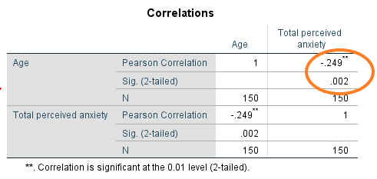
What is the p-value:________________(0.002)
What is the r value:__________________(-0.249)
What is the conclusion:___________________ (significant, weak, negative relationship)
What is the sample size?____________(150)

2.
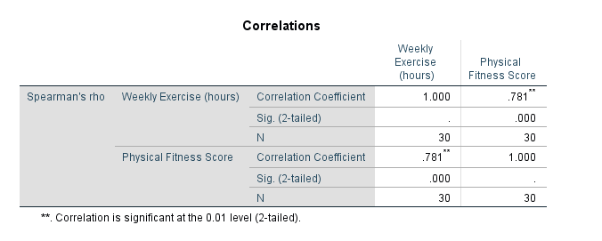
What is the p-value:____________(0.000)
What is the r value:_________________(.781)
What is the conclusion:_______________________(significant, strong, positive relationship)
What is the sample size:______________________(30)

3. 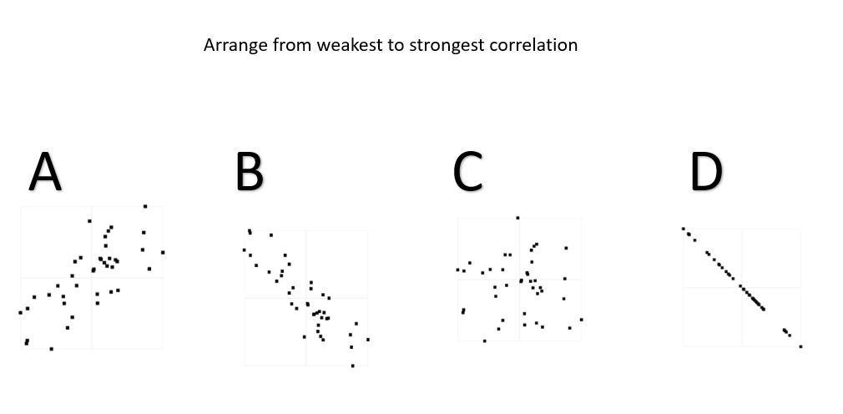
________________________________
(C,A,B,D)

4.
Correlation Matrix
 |  |  |  | perf_reliability |  | perf_initiative
perf_reliability |  | Pearson's r |  | —
 |  | p-value |  | —
perf_initiative |  | Pearson's r |  | 0.185 |  | —
 |  | p-value |  | 0.058 |  | —

Assuming the above data is linear, what is the correct conclusion?______________(not significant, weak positive)

5.

Correlation Matrix
 |  |  |  | seniority |  | age
seniority |  | Pearson's r |  | —
 |  | p-value |  | —
age |  | Pearson's r |  | 0.882 |  | —
 |  | p-value |  | < .001 |  | —
Assuming the above data is linear, what is the correct conclusion?_____________________(significant, strong, positive relationship)

T-Test

What do you need to know:
    - When do you use a T-test
    - What are the data prerequisites
    - What are the 3 different types of T-test
    - How do you read an output window of a T-test
    - What do you do when the pre-requisites are not met.

Fill in the Blank

- A __________ t-test is used to compare the means of two independent groups. (independent)
- A __________ t-test is used to compare the means of the same group at two different times. ( paired sample)
- A _______________ t-test is used when comparing the sample mean to a known value. (one-sample)
- A t-test must meet the requirements of ______________ and ___________________ in order to be considered valid. (homogeneity of variance and normality).
- If the test requirements are not met, a _________________ test is performed (Mann-Whitney U)
- A t-test compares the ___________ of two groups. (means)
- A significant t-test indicates that we can conclude that our means are _________________. (different)
- ______________test is used to assess homogeneity of variance. (Levene’s)

Multiple Choice

Which assumption is crucial to consider when conducting a T-test?
- Equal Variance
- Confidence interval
- Dependence
- Sample Size

Which test should be used if assumptions for a standard T-test are violated?
- Independent T-test
- Paired sample T-test
- One-sample T-test
- Mann-Whitney U test

A school wants to compare the average exam scores of two different groups of students—those who took an online course and those who attended in-person classes. The scores are collected independently for each group. Which t-test should be used?

- Paired t-test
- Independent samples t-test
- One-sample t-test
- Mann-Whitney U test

Which assumption must be met for a T-test to be valid?
- The data must have homogeneity of variance.
- The data must be normally distributed.
- There must be at least one interval/ratio variable and two categorical variables.
- All of the above.

A restaurant management team wants to see if a new training program improves employee performance. They measure the performance of 30 employees before and after the training program. Which t-test should be used?
- Paired t-test
- Independent samples t-test
- One-sample t-test
- Mann-Whitney U test

A tourism research team is interested in testing whether the average room occupancy rate in a particular hotel is significantly different from the national average. They gather data from 50 random days. Which t-test should be used?
- Paired t-test
- Independent samples t-test
- One-sample t-test
- A T-test cannot be performed on this data

A hotel manager wants to compare the customer satisfaction ratings between two groups: customers who booked their stay via an online platform and customers who booked directly with the hotel. The satisfaction ratings are on a scale from 1 to 10, but the data is not normally distributed. Which test should be used?

- Paired t-test
- Independent samples t-test
- Mann-Whitney U test
- One-sample t-test

A study aims to determine whether there is a difference in the average satisfaction ratings between business travelers and leisure travelers for a hotel chain. Data is collected from 50 business travelers and 50 leisure travelers. Levene’s test has a p-value of 0.5. Which t-test should be used?
- Paired t-test
- Independent samples t-test
- One-sample t-test
- Two-way ANOVA

A tourism agency wants to determine if the average number of tourist arrivals in a city differs significantly from the expected national average. They collect data from a sample of 60 days. Which t-test should be used?
- Paired t-test
- Independent samples t-test
- One-sample t-test
- Mann-Whitney U test

A hotel chain wants to see if there is a significant difference in the number of complaints received from two different branches of their hotel. Levene’s test results in a p-value of 0.049.
Which test should be used?
- Independent t-test
- Mann-Whitney U test
- Paired t-test
- Correlation

A researcher is testing whether a group of guests’ average check-in time is significantly different from the industry standard of 5 minutes.
Which test should be used?
- One-sample t-test
- Independent t-test
- Chi-squared test
- Mann-Whitney U test

What is the purpose of a T-test?
- To see if there is a relationship between two categories
- To compare the means of more than two groups
- To see if there is a relationship between a categorical variable and a continuous variable
- To compare the means of one two groups

Output

1.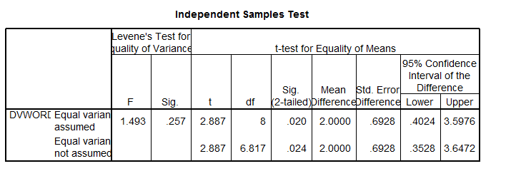
What is the outcome of Levene’s test:___________(p=0.257 therefore not sig)
What p-value should be reported from the t-test, assuming it was a 2-tailed test?________(p=0.02)
What p-value should be reported from the t-test, assuming it was a 1-tailed test?________(p=0.01)

2.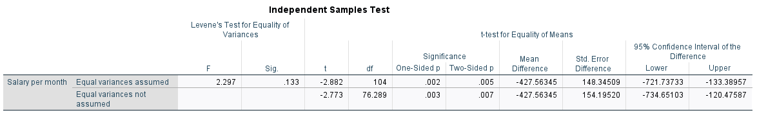
I want to know if there is any difference in salary dependant on gender. What is the p-value I should report?_______(p=0.005)
Is Levene’s test significant? Yes/No (No)
What does this tell us about our data? ________(It has homogeneity of variance/ equal variance)

3.
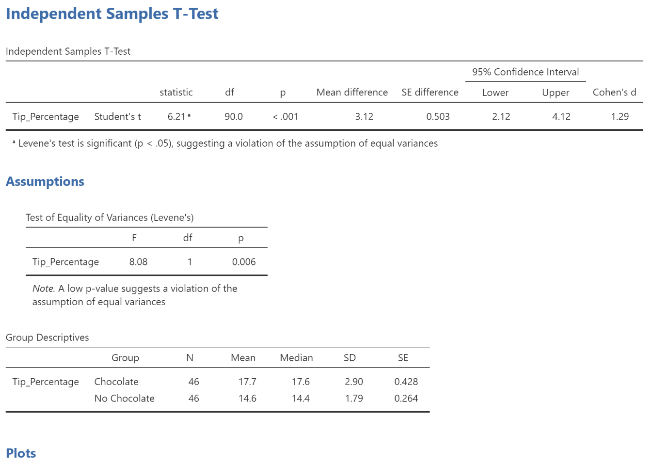
The above analysis was done to see if leaving a chocolate for a guest increased their likelihood of tipping. What can we conclude?
_______________________(We cannot conclude anything, because Levene’s test is significant. We would need to run a Mann-Whitney U test)

How many people were sampled per group? _______(46)

4.
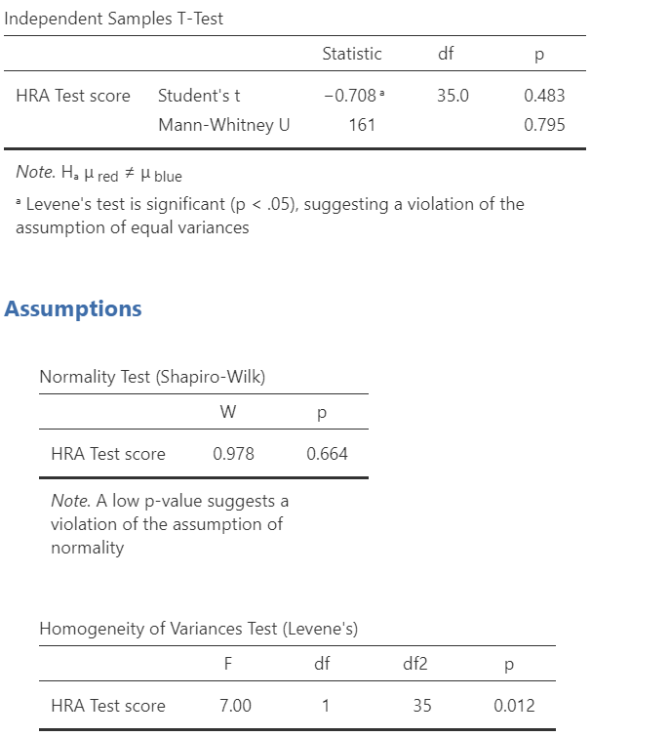

I want to know if the colour of shirt the student was wearing caused any difference in their test score. What p-value do I need to report in my findings? ___________ (0.795)
Why?__________(Levene’s test is significant)

ANOVA
What do you need to know:
    - When do you use a ANOVA
    - What are the data prerequisites
    - How do you read an output window of a ANOVA
    - What is a post-hoc test
    - What do you do when the pre-requisites are not met.

Fill in the Blank

- ANOVA is used to compare the means of __________ or more groups. (three)
- The null hypothesis in ANOVA states that the means of all groups are __________.(equal)
- If ANOVA results are significant, a __________ test is needed to determine which specific groups differ from each other. (post-hoc)
- If Levene’s test produces a significant result (p < 0.05), it suggests that the group variances are __________. (unequal/ non-homogeneous)
- If Levene’s test is positive, and we cannot run an ANOVA F-test, we must run a _________(Welch test).
- The __________ post-hoc test is commonly used when the assumption of homogeneity of variances is met. (Bonferroni/ Tukey)
- The __________ post-hoc test can be used when the assumption of equal variances is violated. (Games-Howell)

Multiple choice

What is the primary purpose of ANOVA?
- To compare the means of two groups
- To test for normality in data
- To compare the means of three or more groups
- To measure the variance within a single group

If ANOVA yields a significant p-value, what is the logical next step?
- Conclude that all group means are same
- Perform a post-hoc test to find which groups differ
- Make a new alternate hypothesis
- Perform a t-test on each group pair

If Levene’s test shows a significant result (p < 0.05), it means that the variances are __________ across groups.
- equal
- unequal
- normally distributed
- independent

When Levene’s test indicates unequal variances, which of the following is an appropriate action?
- Perform standard ANOVA
- Use the Welch Test
- Assume variances are equal anyways
- Run a correlation analysis

Which post-hoc test adjusts for multiple comparisons to reduce the risk of Type I errors?
- Tukey's HSD
- Bonferroni
- Levene’s test
- Games-Howell test

Post-hoc tests are needed after a significant ANOVA because an ANOVA only tells us that __________.
- group variances are unequal
- all group means are significantly different
- the data is not normally distributed
- at least one group differs, but not which ones

Output

1.
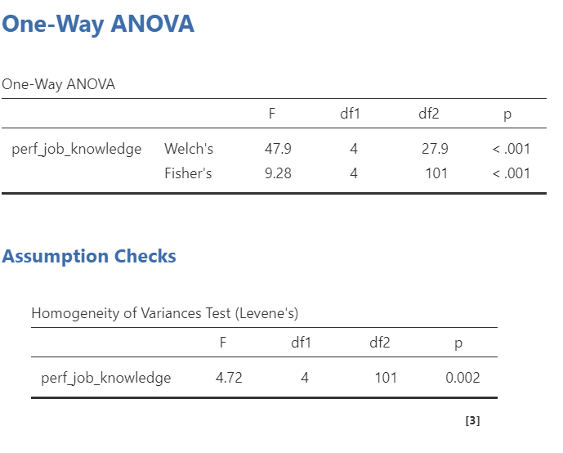
What ANOVA test is the correct one, based on the information give above?_______(Welch)
What is the follow up post-hoc that should be done? ____________(Games-Howell)

2.
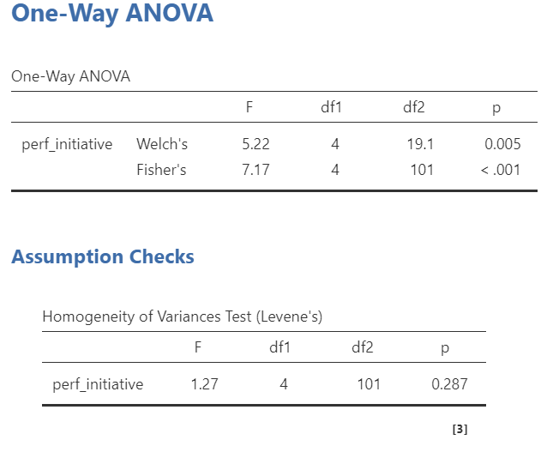
What is the appropriate test result to report, based on the information available in the above image?___________(Fishers/ ANOVA F/ p<0.001)
What post-hoc test should be done? ________________(Bonferroni/ Tukey)

3.
Tukey Post-Hoc Test – perf_initiative
 |  |  |  | 1 |  | 2 |  | 3 |  | 4 |  | 5
1 |  | p-value |  | — |  | 1.000 |  | 0.944 |  | 0.002 |  | 0.036
2 |  | p-value |  |  |  | — |  | 0.941 |  | < .001 |  | 0.027
3 |  | p-value |  |  |  |  |  | — |  | 0.009 |  | 0.028
4 |  | p-value |  |  |  |  |  |  |  | — |  | 0.976
5 |  | p-value |  |  |  |  |  |  |  |  |  | —
Note. * p < .05, ** p < .01, *** p < .001

Based on the above post-hoc test, what group pairing has the strongest statistical difference?
__________________(2-4)
What groups have no statistical differences between them?_____________________(1-2, 1-3, 2-3, 4-5)

4.
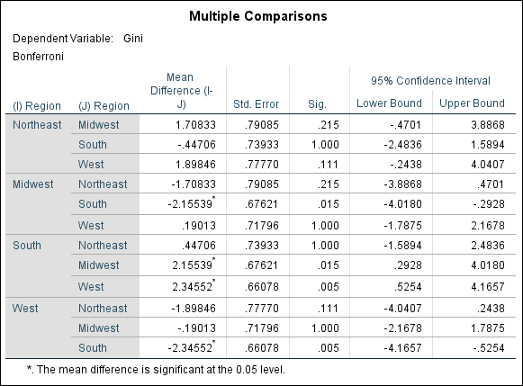

Based on the above image, are there any differences between region and religion? Yes/no (yes)
If yes: What groups differ? ___________________________________________(Midwest-south, south-west)
If no: Why not?__________________________________________________(this is not the correct answer)

Walk through

- You collect continuous data from 3 groups of people. You want to compare it to see if there any differences between the groups. To do an ANOVA analysis, your data must meet a certain rule. What is it? _________________________(Homogeneity of Variance)
How do we test if the data meets this rule? ______________________(Levene’s test).

Your data meets the requirements necessary to proceed and do a regular ANOVA F-test. The result is significant. If we stop here, what can we conclude? _____________________(There is a difference between our groups, but we are not sure which ones.)

To make our result more useful, we can follow up a significant ANOVA F-test with a post-hoc test. What are the appropriate tests to use? ____________________________(Bonferroni/ Tukey)
If our data did NOT meet the requirements necessary to run a standard ANOVA F-test, we should have done a ________________. (Welch test)

To follow up the aforementioned test with a post-hoc, we should choose the __________________post-hoc test. (Games-Howell)

